# *Update to:* [*https://blog.registryfinder.com/personalized-gifts-bridesmaids-groomsmen/*](https://blog.registryfinder.com/personalized-gifts-bridesmaids-groomsmen/)

# 

# *Best Personalized Gifts for Your Wedding Party*

*Show each individual in your bridal party just how much you appreciate them with a personalized gift before the wedding.*

There is nothing accidental about a bridal party. Each bridesmaid and groomsman holds a special place in your lives as a couple — whether they’re childhood friends, siblings, or college buddies — and they’ve likely weathered plenty of life’s ups and downs right by your side. And your wedding day is no different — you picked them to stand next to you for a reason.

If you’ve ever been part of a bridal party, you know to be ready for anything leading up to the big day. Your closest friends and loved ones are the ones who will stay up all night, helping with seating arrangements and sending last-minute emails to the wedding planner when the unexpected happens.

How can you possibly show your appreciation for every member of your bridal party? One of my favorite ways is to present each person with a personalized gift at the rehearsal dinner or on the wedding day. It’s a moment when you know you’ll all be together, and the culmination of everyone’s efforts will be on full display — a great time to celebrate each other. Below, we’ve put together our top picks that your bridesmaids and groomsmen will love.

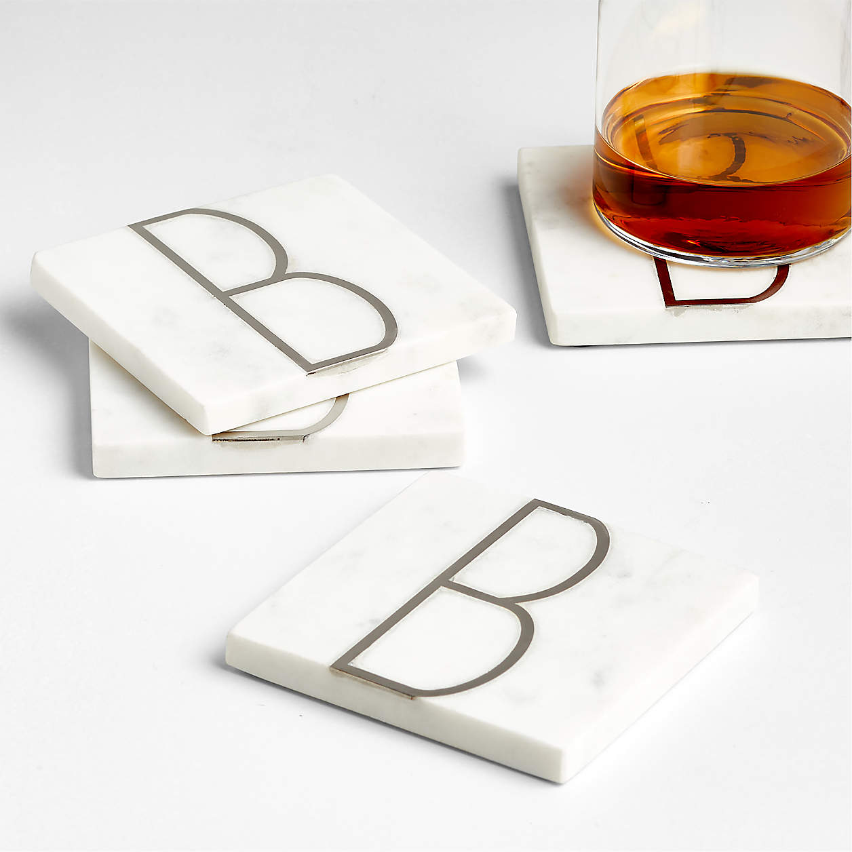

<https://www.anrdoezrs.net/click-5902382-13311537?sid=blog-wed--&url=https%3A%2F%2Fwww.crateandbarrel.com%2Fmarble-k-monogram-coasters-set-of-4%2Fs390856%3Flocaledetail%3DUS%26a%3D1552%26campaignid%3D10461646761%26adgroupid%3D103999389499%26targetid%3Dpla-296417366369%26pla_sku%3D390856%26pcat%3DHSW%26ag%3Dadult%26scid%3Dscplp390856%26sc_intid%3D390856%26gclid%3DCj0KCQjw2qKmBhCfARIsAFy8buJ4GK19v2m-lHX_qne6LOPEFTWfBQnZbTbDzSl_MOZztfD_nU7USyAaAlKQEALw_wcB>

Classic, elegant, and totally customized for your bridal party, these marble coasters are a great gift.

# Monogrammed Marble Coaster Set

You can’t go wrong with a set of [personalized coasters](https://www.anrdoezrs.net/click-5902382-13311537?sid=blog-wed--&url=https%3A%2F%2Fwww.crateandbarrel.com%2Fmarble-k-monogram-coasters-set-of-4%2Fs390856%3Flocaledetail%3DUS%26a%3D1552%26campaignid%3D10461646761%26adgroupid%3D103999389499%26targetid%3Dpla-296417366369%26pla_sku%3D390856%26pcat%3DHSW%26ag%3Dadult%26scid%3Dscplp390856%26sc_intid%3D390856%26gclid%3DCj0KCQjw2qKmBhCfARIsAFy8buJ4GK19v2m-lHX_qne6LOPEFTWfBQnZbTbDzSl_MOZztfD_nU7USyAaAlKQEALw_wcB) for your bridal party, and this marble set is a great gifting option. The artful design is subtle enough to blend into any decor style, so your bridal party will appreciate this thoughtful, practical gift.

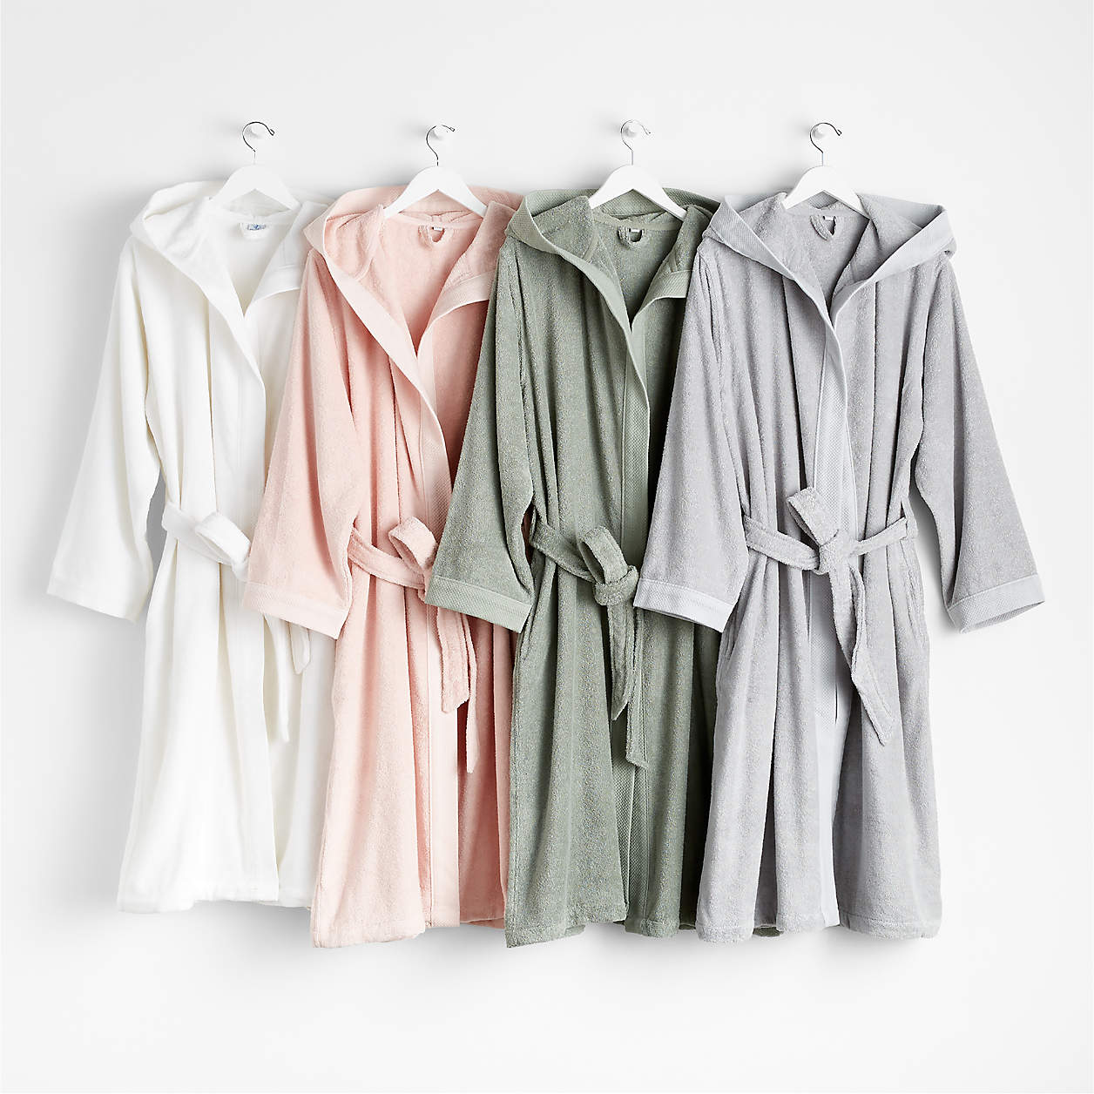

<https://www.kqzyfj.com/click-5902382-13311537?sid=blog-wed--&url=https%3A%2F%2Fwww.crateandbarrel.com%2Forganic-turkish-grey-cotton-bathrobe-l-xl%2Fs434162>

Everyone needs a cozy robe for lounging around — making it a perfect, personalized gift for your bridesmaids and groomsmen.

# Turkish Cotton Robe

With the option to embroider with a first name or single initial, your bridesmaids or groomsmen will always know which super-soft, quick-drying [Turkish cotton robe](https://www.kqzyfj.com/click-5902382-13311537?sid=blog-wed--&url=https%3A%2F%2Fwww.crateandbarrel.com%2Forganic-turkish-grey-cotton-bathrobe-l-xl%2Fs434162) is theirs. The full-length robe is a thoughtful gift that they’re guaranteed to use for a long time.

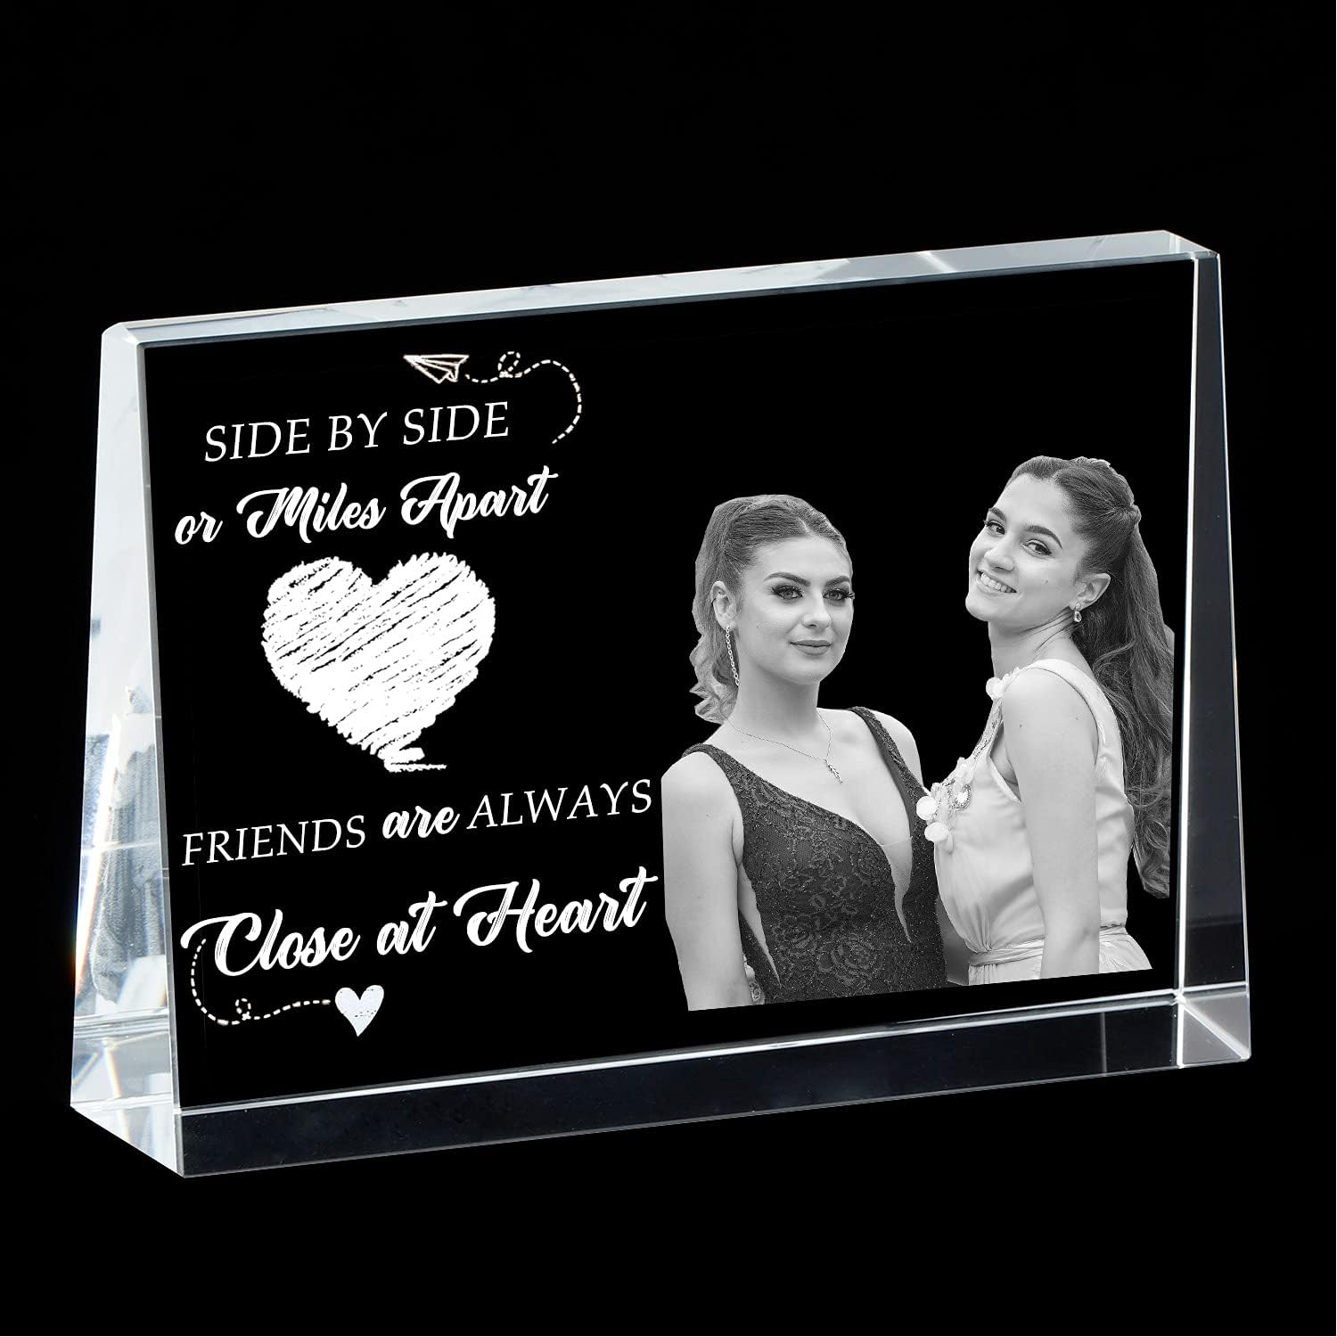

<https://www.amazon.com/Personalized-Friendship-Birthday-Customized-Graduation/dp/B097H3YC7F?source=ps-sl-shoppingads-lpcontext&ref_=fplfs&smid=ASBBY1CU0SQ8V&th=1&tag=rfcomblog-20>

Find your favorite photo with each member of your bridal party and gift it to them in a custom memento that shows your appreciation.

# Picture Frame

If you’re looking for a super personal gift, grab a customizable [picture frame](https://www.amazon.com/Personalized-Friendship-Birthday-Customized-Graduation/dp/B097H3YC7F?source=ps-sl-shoppingads-lpcontext&ref_=fplfs&smid=ASBBY1CU0SQ8V&th=1&tag=rfcomblog-20). This option allows you to have a picture from a cherished memory you’ve shared forever etched into the glass, making it an extra special gesture of your appreciation.

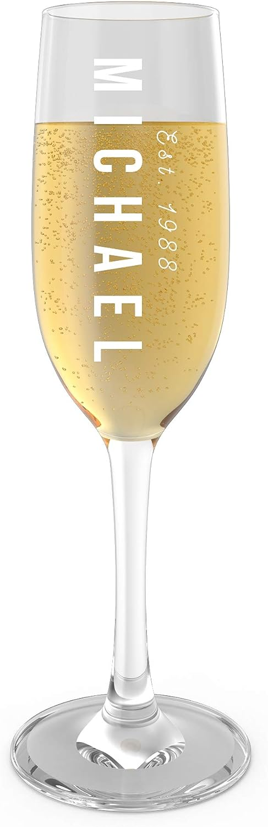

<https://www.amazon.com/Customized-Happy-Birthday-Toasting-Flute/dp/B085LM3579?source=ps-sl-shoppingads-lpcontext&ref_=fplfs&psc=1&smid=A2CJAPOIRYC5HO&tag=rfcomblog-20>

Give your bridal party an excuse to celebrate your nuptials long after the wedding with a custom Champagne flute as a thank-you gift.

# Champagne Flute

Sure, plenty of people own Champagne flutes, but how many have one with their name engraved into it? These [classic glasses](https://www.amazon.com/Customized-Happy-Birthday-Toasting-Flute/dp/B085LM3579?source=ps-sl-shoppingads-lpcontext&ref_=fplfs&psc=1&smid=A2CJAPOIRYC5HO&tag=rfcomblog-20) are a nod to celebration and cheers — perfect for the people celebrating your wedding by your side — and can be customized with up to 40 characters. Pair it with a bottle of prosecco for ready-to-enjoy gifting!

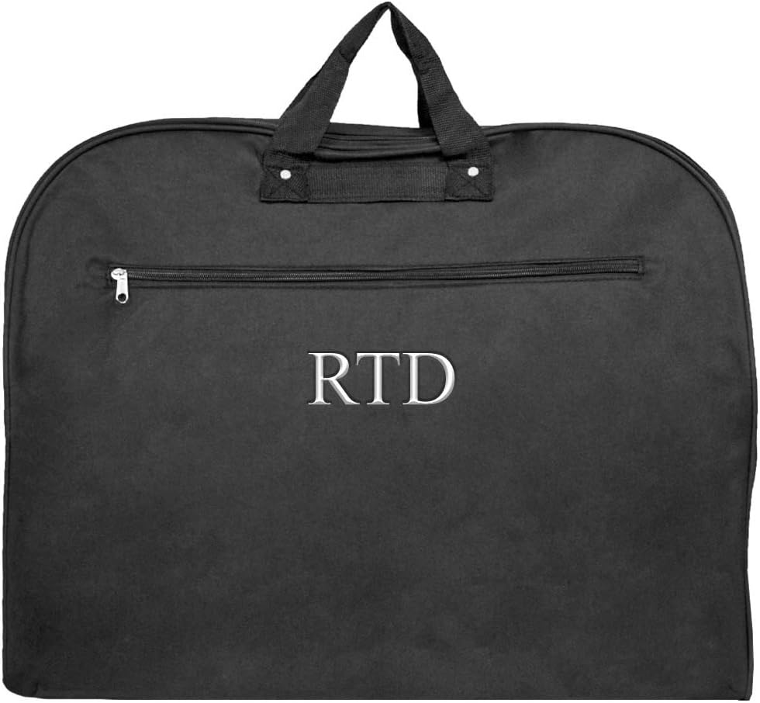

<https://www.amazon.com/Personalized-Unisex-Garment-Luggage-Bags/dp/B01N3LSJYO?source=ps-sl-shoppingads-lpcontext&ref_=fplfs&psc=1&smid=A3I7GMWF77AKVE&tag=rfcomblog-20>

Destination wedding? Gift your bridal party with monogrammed garment bags to safely get their duds from point A to point B.

# Garment Bag

Planning a destination wedding? Gift your bridal party with a [personalized garment bag](https://www.amazon.com/Personalized-Unisex-Garment-Luggage-Bags/dp/B01N3LSJYO?source=ps-sl-shoppingads-lpcontext&ref_=fplfs&psc=1&smid=A3I7GMWF77AKVE&tag=rfcomblog-20) ahead of the big day so they can transport their precious cargo without worrying about wrinkles. This option sports a full-length opening and plenty of extra storage space for shoes and accessories.

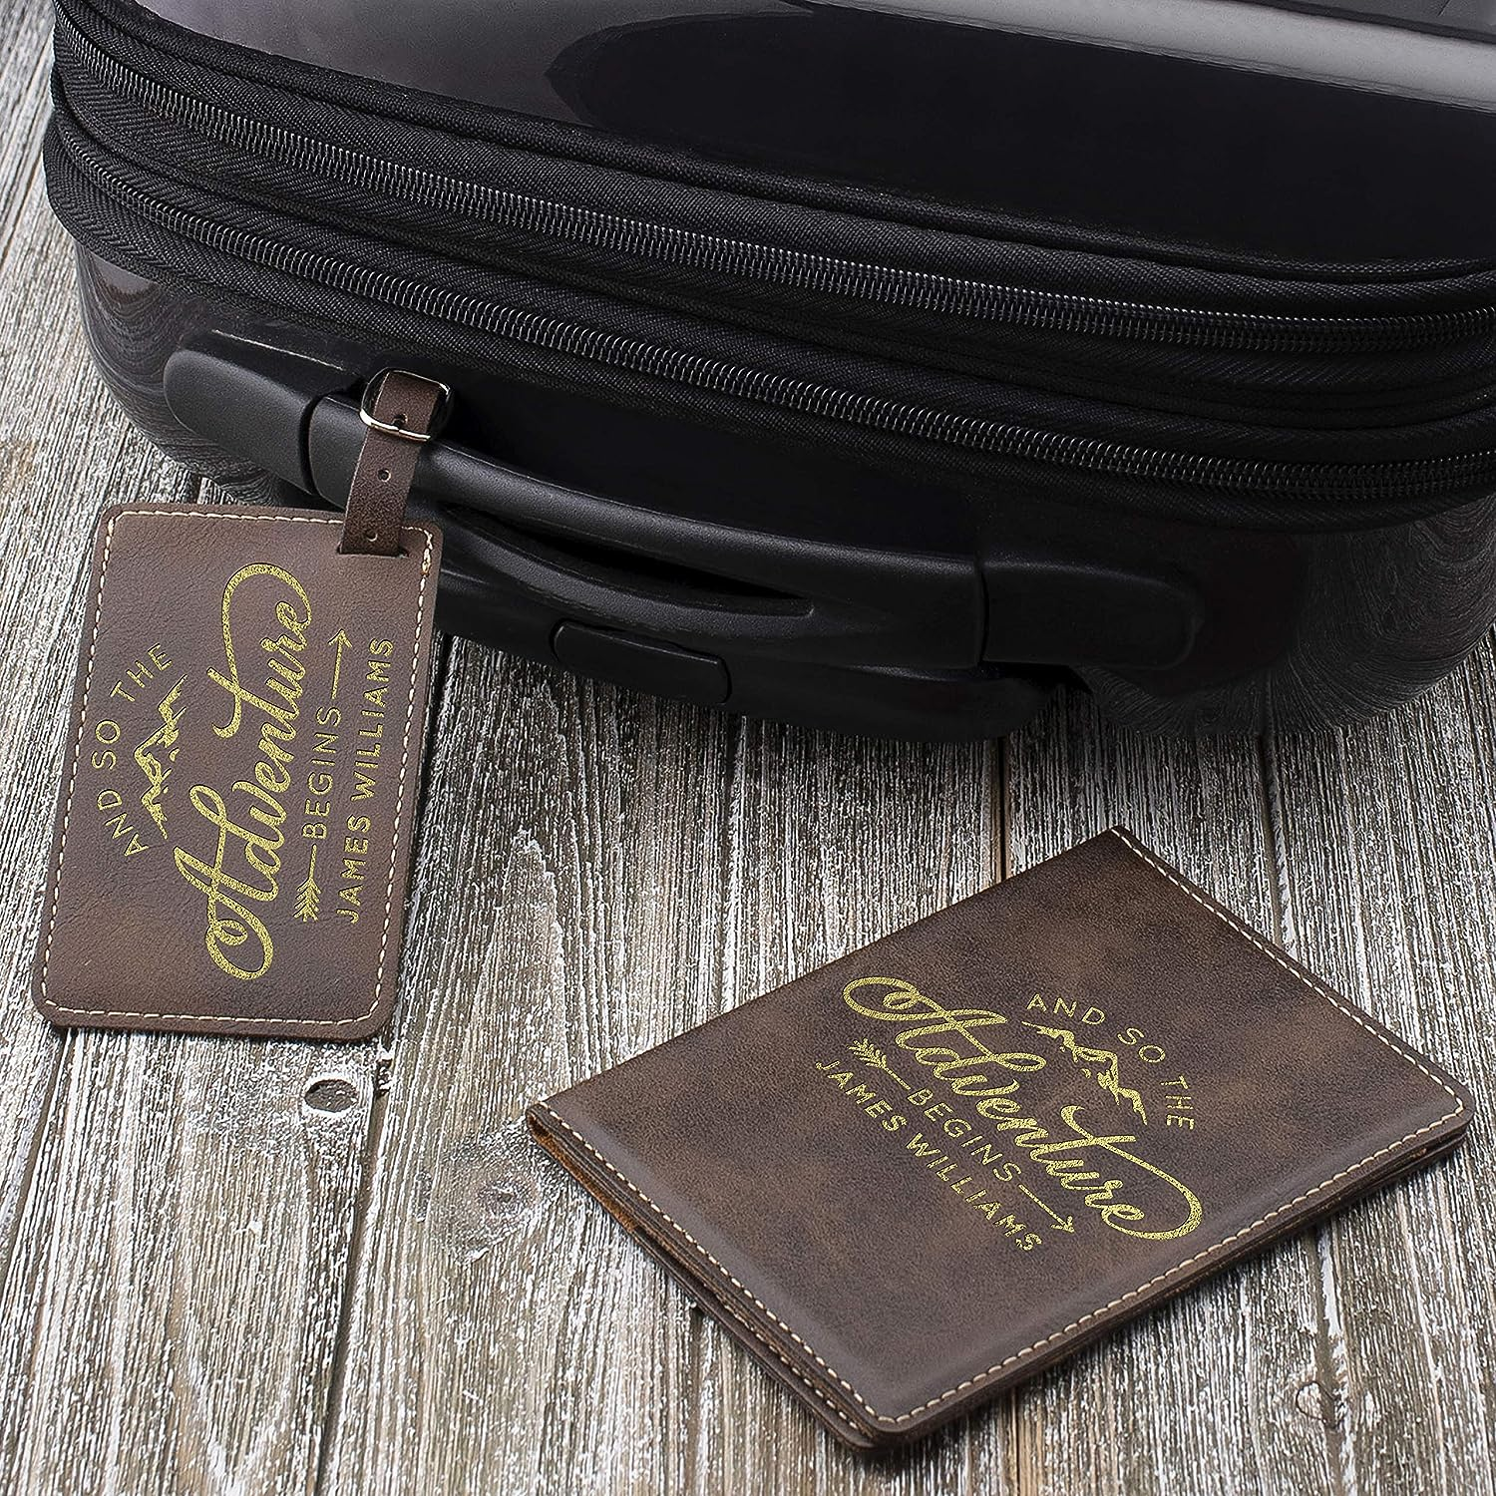

<https://www.amazon.com/Personalized-Leather-Passport-Engraved-Suitcase/dp/B07W8NTK54?source=ps-sl-shoppingads-lpcontext&ref_=fplfs&smid=ARJ64Q0HJL63I&th=1&tag=rfcomblog-20>

If your bridal party is traveling for your wedding, show your support with a personalized passport holder and luggage tag.

# Leatherette Passport Holder & Luggage Tag

Another option for those of you planning a destination wedding — an international one, in particular — is a dual gift of a personalized [passport holder and luggage tag](https://www.amazon.com/Personalized-Leather-Passport-Engraved-Suitcase/dp/B07W8NTK54?source=ps-sl-shoppingads-lpcontext&ref_=fplfs&smid=ARJ64Q0HJL63I&th=1&tag=rfcomblog-20). The leatherette passport holder includes interior pockets for travel documents, so you can rest assured everyone will arrive at the destination.

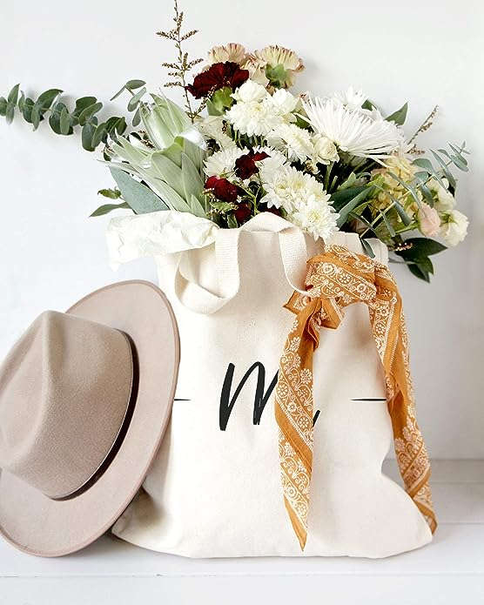

<https://www.amazon.com/Cotton-Canvas-Co-Personalized-Resusable/dp/B07NSSYT5K?source=ps-sl-shoppingads-lpcontext&ref_=fplfs&smid=A3GHCKOMK63GYN&th=1&tag=rfcomblog-20>

For the bridal party that had to endure all your wedding planning baggage, gift them with a customized canvas tote to show your thanks.

# Canvas Tote

Your bridal party has probably carried you through some challenging scenarios — wedding-related and otherwise. Gift them with a [tote bag](https://www.amazon.com/Cotton-Canvas-Co-Personalized-Resusable/dp/B07NSSYT5K?source=ps-sl-shoppingads-lpcontext&ref_=fplfs&smid=A3GHCKOMK63GYN&th=1&tag=rfcomblog-20) that can carry everything they need from place to place as a thanks for everything they’ve done for you. Each canvas tote can be customized with an added design that matches everyone’s personality and style.

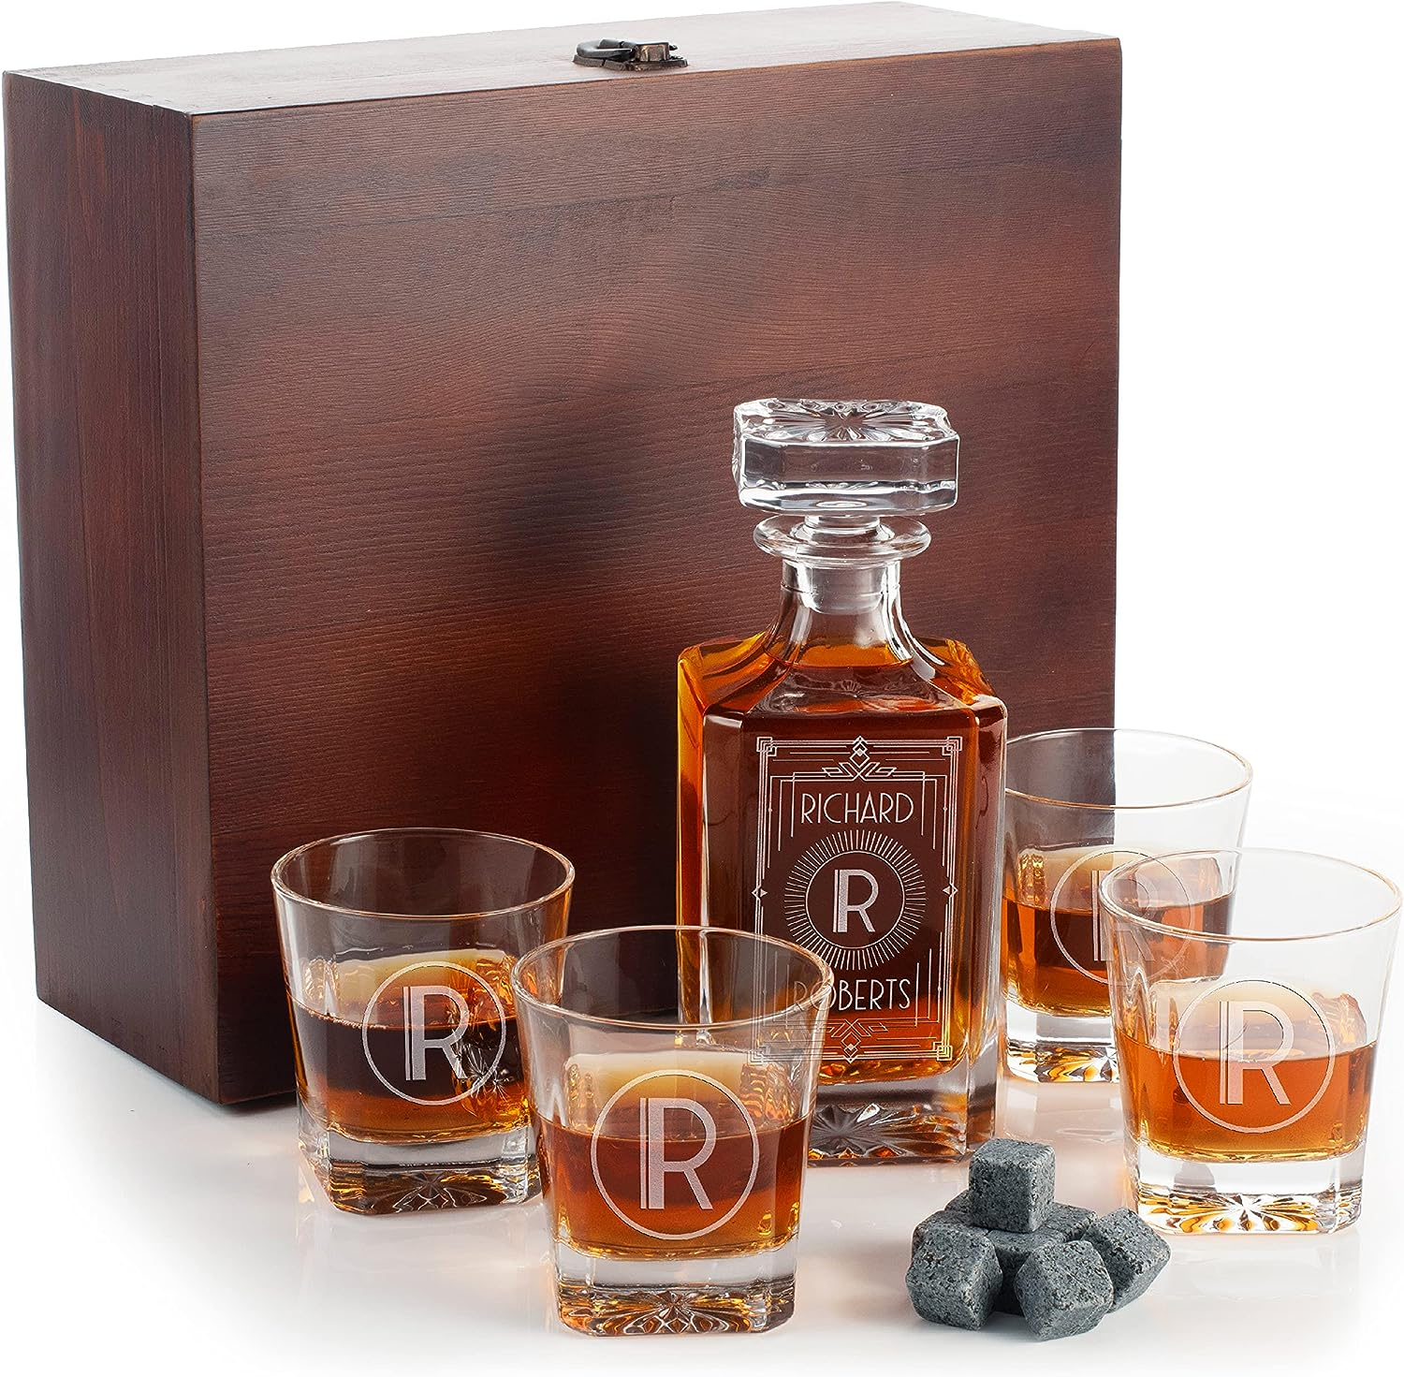

<https://www.amazon.com/Personalized-Whiskey-Decanter-Set-Glasses/dp/B0BCQBVZRP?source=ps-sl-shoppingads-lpcontext&ref_=fplfs&smid=A33U1EV8ID8Y8C&th=1&tag=rfcomblog-20>

No matter their spirit of choice, your bridal party members will love being able to serve it in a custom decanter and glasses.

# Whiskey Decanter & Glasses

A personalized [whiskey decanter and set of drinking glasses](https://www.amazon.com/Personalized-Whiskey-Decanter-Set-Glasses/dp/B0BCQBVZRP?source=ps-sl-shoppingads-lpcontext&ref_=fplfs&smid=A33U1EV8ID8Y8C&th=1&tag=rfcomblog-20) add a touch of class to any home bar and make a great gift for anyone in your party who appreciates a good drink. They’ll have so many fond memories to look back on every time they fill a glass.

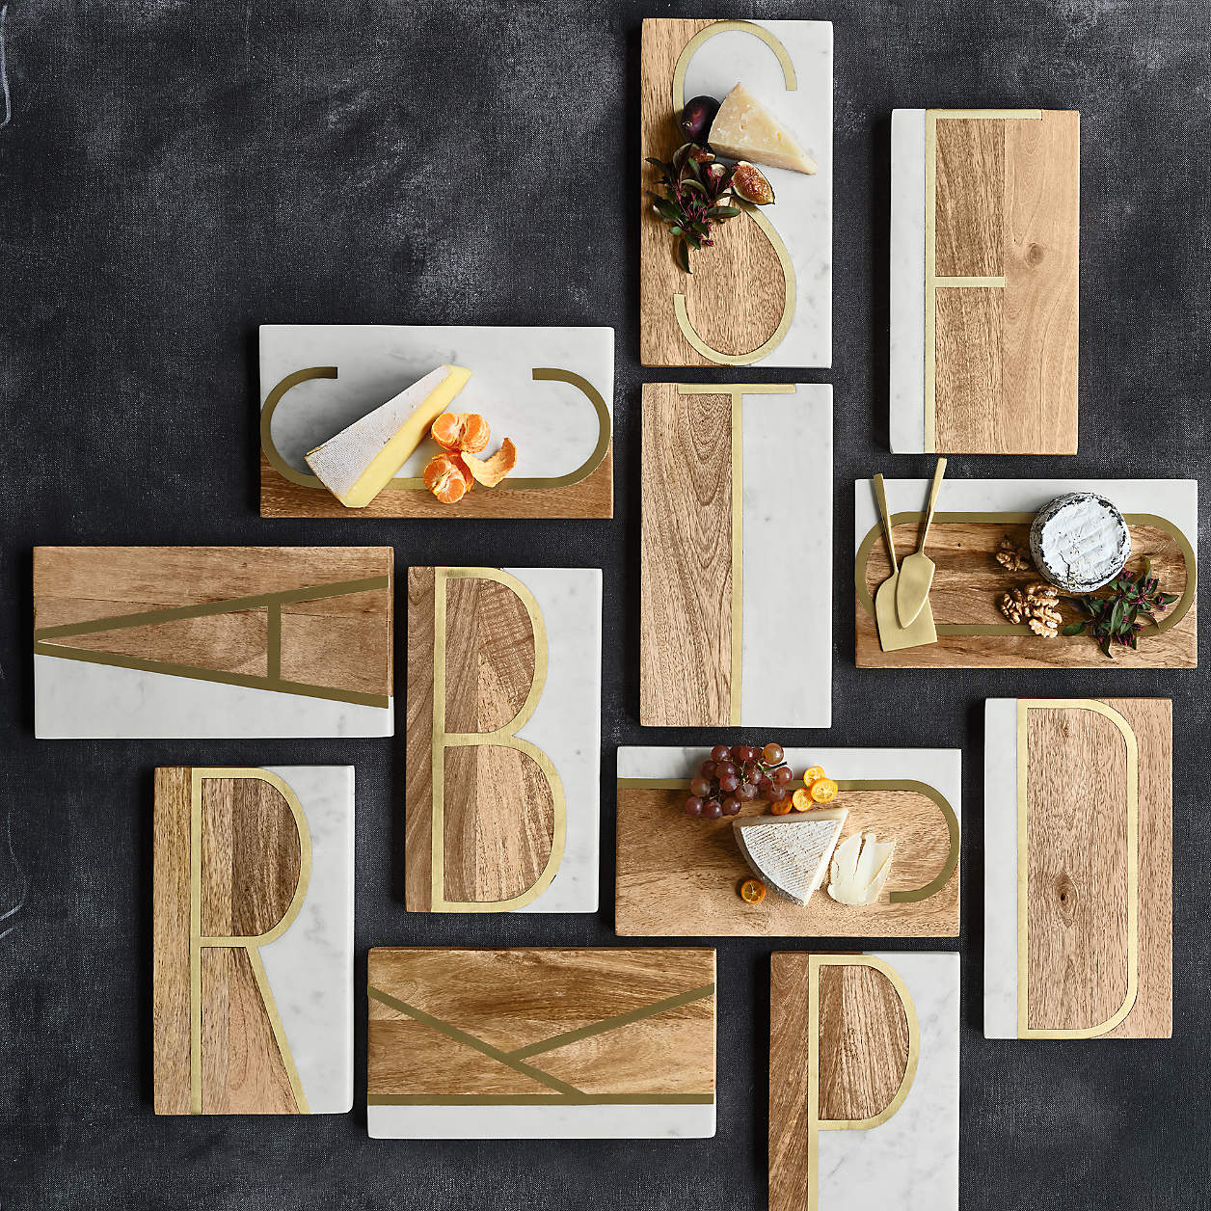

<https://www.anrdoezrs.net/click-5902382-13311537?sid=blog-wed--&url=https%3A%2F%2Fwww.crateandbarrel.com%2Fe-monogrammed-serving-board%2Fs144906>

Gift your bridesmaids and groomsmen with a custom serving board as an excuse to hang out and eat more cheese with them.

# Monogrammed Serving Board

Who doesn’t love a good cheese board? This [monogrammed marble board](https://www.anrdoezrs.net/click-5902382-13311537?sid=blog-wed--&url=https%3A%2F%2Fwww.crateandbarrel.com%2Fe-monogrammed-serving-board%2Fs144906) features an oversized initial to make a bold statement at any gathering. Add a bottle of wine or a gift card to a local cheesemonger for a perfect pairing!

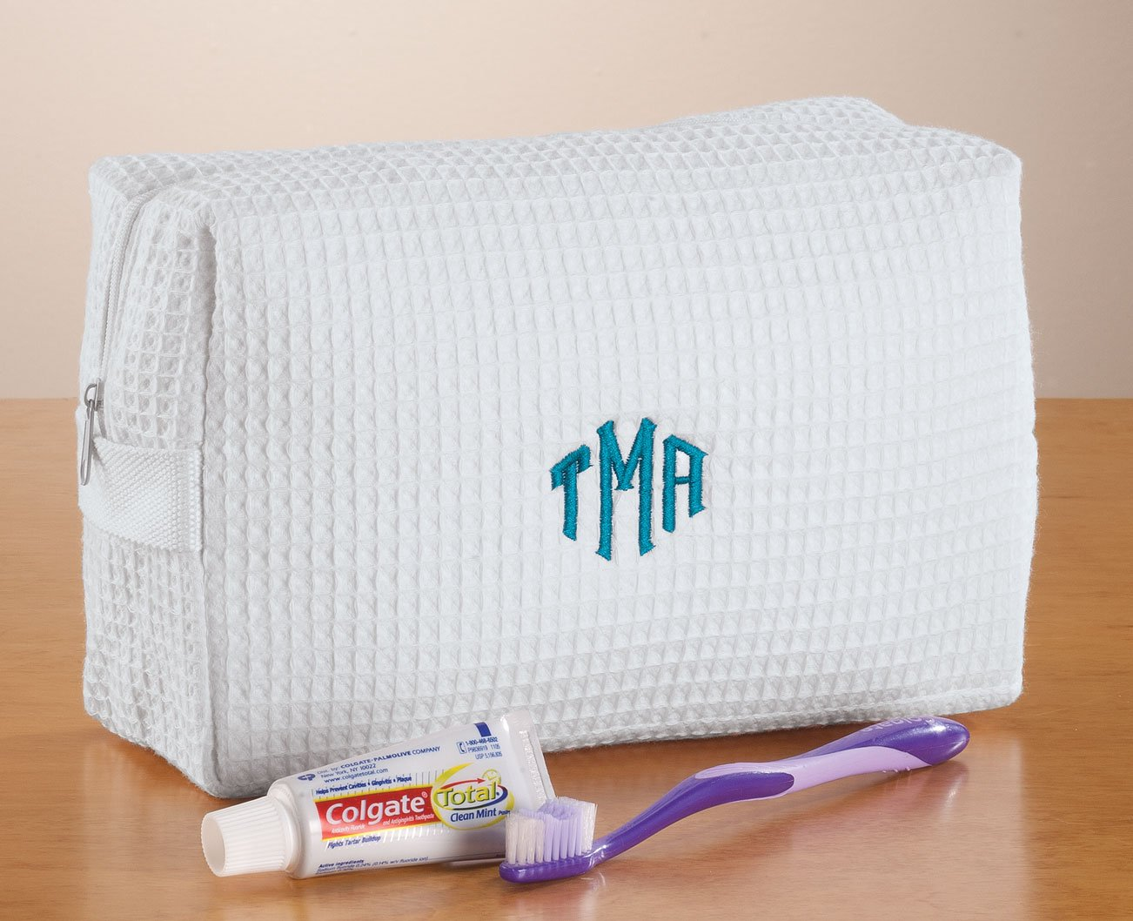

<https://www.amazon.com/Personalized-Waffle-Cosmetic-Bag-White/dp/B074JMFHL3?source=ps-sl-shoppingads-lpcontext&ref_=fplfs&psc=1&smid=A26SZT7ECSJVFI&tag=rfcomblog-20>

Monogrammed toiletry bags make a practical, classic gift for your bridal party.

# Toiletry Bag

I was so jealous when my husband was gifted a personalized [toiletry](https://www.amazon.com/Personalized-Waffle-Cosmetic-Bag-White/dp/B074JMFHL3?source=ps-sl-shoppingads-lpcontext&ref_=fplfs&psc=1&smid=A26SZT7ECSJVFI&tag=rfcomblog-20) bag for being a groomsman at a recent wedding. The waffled cotton fabric exterior sports a modern monogram, while the interior is lined with protective plastic to keep things clean. It’s a wonderful, customized gift your bridal party will love.

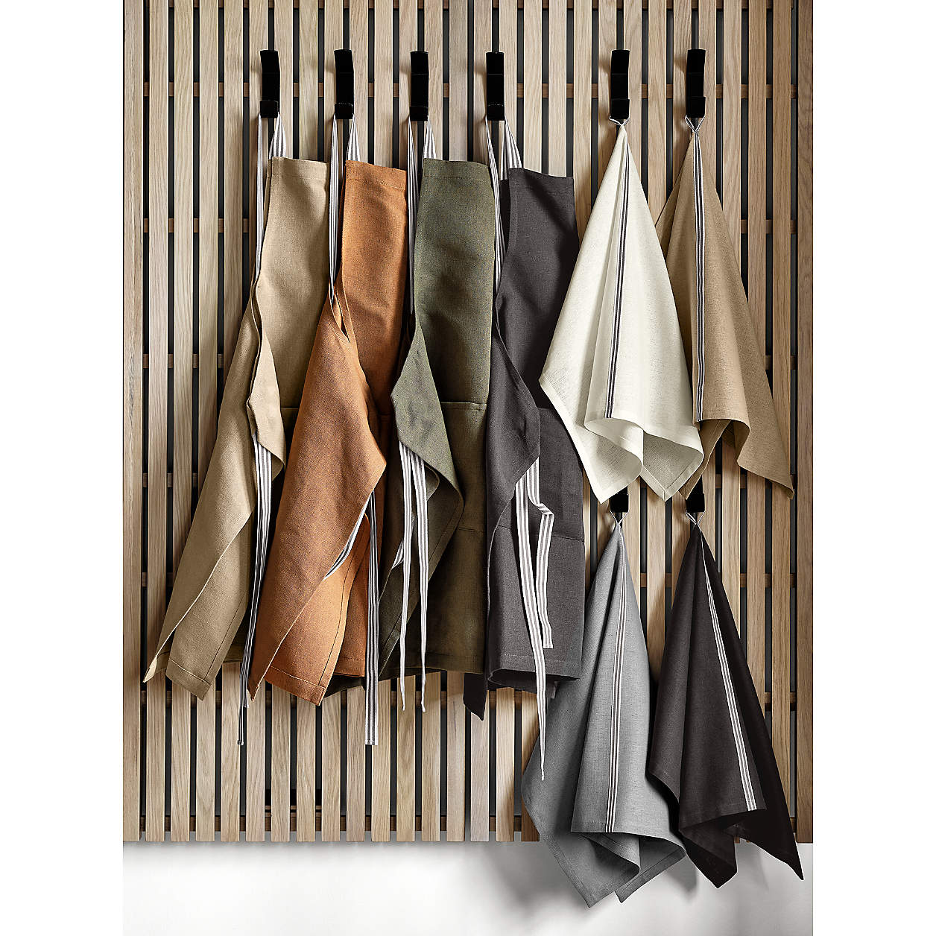

<https://www.jdoqocy.com/click-5902382-13311537?sid=blog-wed--&url=https%3A%2F%2Fwww.crateandbarrel.com%2Foslo-cross-back-brown-apron-with-pocket%2Fs221741>

A good apron is almost as important as solid cookware, so outfit your bridal party with custom kitchen protection!

# Utility Apron

Any home cooks in your bridal party? Upgrade their kitchen gear with a heavy-duty [cotton-linen blend apron](https://www.jdoqocy.com/click-5902382-13311537?sid=blog-wed--&url=https%3A%2F%2Fwww.crateandbarrel.com%2Foslo-cross-back-brown-apron-with-pocket%2Fs221741) that’s *literally* got their name on it. The front pocket comes with a secret interior conversion chart so they can easily multiply and divide recipes, and it softens with every wash — so they can wear any stain and spill with pride.

# Your Wedding Day

Your wedding day is no different from those special moments you’ve shared with your closest friends and relatives — I mean, they’re standing by your side because they’ve been there for most of them. While it’s impossible to show your appreciation in a single gift, we know your bridal party will feel so appreciated when you take the time to gift them something unique and personalized to commemorate their involvement in your life and your special day.